**Wellness emphasized at Southeast Regional CSP Conference**

By Akilah Williams, AdvocacyWorx Program Supervisor

This year’s Southeast regional conference was held in Philadelphia at Jenice’s Event & Conference Center located at 301 E. Godfrey Avenue. Karlene Caparro, chair of the Southeast Regional CSP Conference Committee, wanted to honor CSP’s intention to rotate the location of their annual conference within the various counties that are members. This year’s keynote speakers were Lee and Dennis Horton, officially known as the Horton brothers.

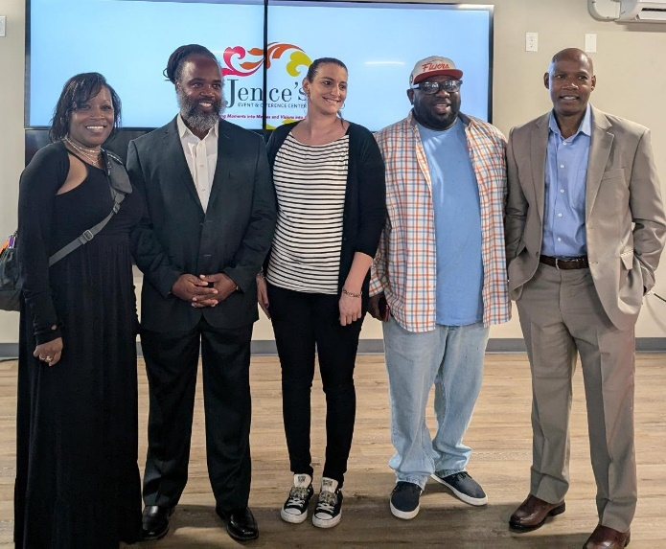 They mentioned, during their speech, that they had grown up just around the corner in Germantown and felt like they were coming full circle. They shared their inspirational story of resiliency and explained how they were able to find a way to foster hope while serving 28 years behind bars before having their prison sentence commuted by Gov. Wolf. During their incarceration, the Horton brothers had the opportunity to become [Certified Peer Specialists](https://dbhids.org/about/organization/strategic-planning-division/peer-culture-and-community-inclusion-unit/certified-peer-specialist-training/) (CPS) through a [training](https://t.e2ma.net/pages/1776550/2958) offered by the Pennsylvania Department of Corrections. They have credited that experience, alongside WRAP (wellness recovery action plan), as the catalyst for a transformative metamorphosis that changed their lives and delivered them from years of underlying trauma, severe anxiety, and depression. As they began using their skills and lived experience to support other incarcerated individuals, they continued to exhibit CSP values and principles pertaining to advocacy, choice, person-centered, and strengths based. The audience was transfixed as they shared how they were able to bear witness to the considerable power of peer support in the lives they touched while incarcerated. They finished with a question-and-answer session before mingling with those in attendance.

The conference attendees proceeded to engage with several wellness activities in alignment with this year’s theme promoting mental wellness and self-care. In addition to karaoke, guests could also engage with an art station hosted by Creating Increased Connections and facilitated by Brenda (CIC), sit for a henna tattoo, or attend a sound bath session with Sally Kaufman from Happy Healthy International. Every guest received a swag bag containing calming strips, a mental health keychain, stickers, an anxiety squishy, a bracelet with an inspirational message, and information about various mental health resources and supports. In between songs and plentiful conversation, people enjoyed baked and fried chicken, green beans, macaroni and cheese, and potato salad. See more photos below.

