**By: Ameika Malcolm, HopeWorx**

Twenty-three campers enjoyed the great outdoors on a June weekend at Green Lane Park, setting up tents, kayaking, taking morning hikes, grilling food and sitting by the campfire.

Many individuals, like Roderick, had never slept outside before going on the annual outings for the past three years.

“I thought… no I am not sleeping outdoors,” Roderick said. “And let me tell you… I not only enjoyed it, I loved it so much, I am going on my 4th camping trip in September.”

Roderick said people are a lot of fun to hang out with and he loves to cook. Now, he is the honorary camp chef.

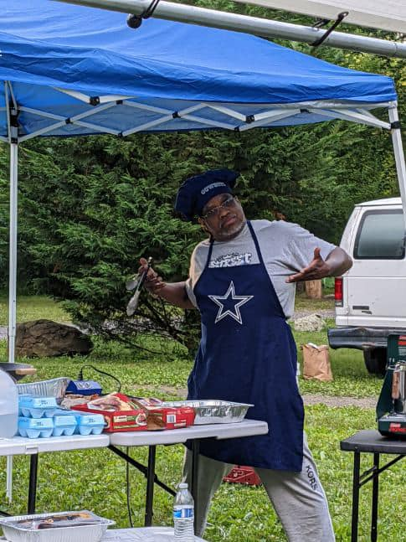

“This makes me happy…from never going camping before this, to camp chef!! One more thing about this group of people… I promise if you come join us you will never find a more supportive group of people… hands down.”

Roderick said the HopeWorx camping trip is a must, where you will find “good people, good times, and good food. I am going back again so come hang out with us and you will be hooked like I am now.”

Summer, another camper who enjoyed the trip, said she hadn’t been camping in a while. She was glad to be outdoors and in the company of very supportive people.

“I thought this camping trip would be something fun and to get me out of the house,” Summer said. “I felt supported on this trip, because while we were hiking, another person and I were unable to follow the trail as it was a bit difficult for us to walk. Another person took the time to take us on an easier path.”

Also, Summer was able to catch up with someone from high school she had not seen in a while. She said she will be going to the next trip, and will invite some of her family members. She said the planning and organizing of the trip was very good and she recommends it to anyone who’s interested.

“Not everyone can handle it, because you will be sleeping outside in a tent with a sleeping bag on the ground,” Summer said. “But it is fun, and I had a good time.”

And just for the record, this was not Glamping, said Danny.

“I enjoyed the camaraderie of everyone just helping each other,” Danny said. “This was my first time camping and I would do it again.”

However, Danny may think twice before going again because he’s not a fan of sleeping on the hard ground or being in the rain. But overall, it was a fine experience where people provided a lot of support although he did go immensely prepared.

“We had a blast,” Danny said. “It was a lot of fun and it opened my eyes and my confidence has gone up.”

Danny said at first things started off a little rocky because they did not know what we were doing, but they managed to get it together. It was the ultimate survival, because we are humans.

“I would recommend this camping trip to first timers; the community is awesome, and you are not going to get the laughs you get at camping,” Danny said.

